
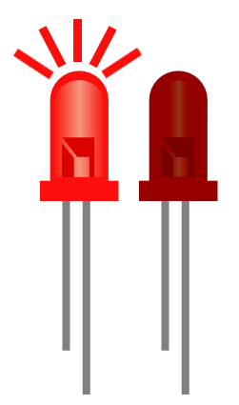
Making an LED Blink Using Scratch V2.0
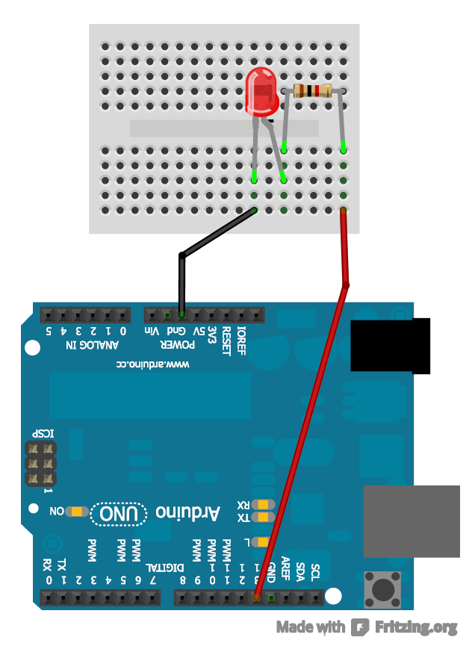
1K ohm Resistor
LED only works if plugged into the circuit the correct way round. The longer leg should
be on the right.

Step 1:
Make sure you have your Arduino ready to work with Scratch. You should have done this already by following the steps in the 'SetupYourArduinoForScratch' document.

Step 2:
Create a circuit like the one to the right. It is important to note that the red wire goes into pin 13 on the Arduino.


Step 3:
Create a block like the one on the left in scratch.
As we have attached an LED to pin 13 we use the 'Set Pin: 13 as output' block to tell the Arduino that there is an output on pin 13 and not an input. Anything that gives out something such as light, sound or motion is an output. Anything that we measure such as sensors are inputs.
We use the 'digitalWrite Pin 13 as high/low' block to turn on or off pin 13 and hence turn on or off the LED. High means on and low means off. So this block is turning on pin 13, waiting a second, turning off pin 13, waiting a second and then repeating. Hence you should see a blinking

Extension:
We can plug the red lead into any digital pin (2-13). We are not just limited to pin 13. If we move the red lead to pin 10 then all we have to do to get it working is change the Scratch code to use pin 10. Now try to construct a second LED circuit, plugging it into a pin other than 13 and get scratch to flash both LEDs

How does this all work?

When we turn on pin 13, the pin is 5V and when we turn it off the pin is 0V. The GND pin is also 0V. When we create a circuit that has a difference in voltage, for example one pin is 0V and the other is 5V (like when we turn on pin 13 in our circuit) we get current flowing. We don't however get a current flowing when there is no difference, for example one pin is 0V and the other is also 0V (like when we turn off pin 13).
Electric current is the flow of electric charge so when we have current flowing we will have power going to the components connected in that circuit. In our case when current is flowing power goes to the LED and turns it on.
The resistor is used to limit the amount of current that flows to the LED, too much current will break it so without the resistor the LED would burn up and break. You can think of a resistor as a tap you might find in your sink, without the tap water would flow out really fast but with the tap you can control how fast the water comes out. The higher the resistance of a resistor, measured in ohms, the smaller the current is. We used a 1K ohm resistor in our example, try switching it for a larger resistor such as 10K ohm and you will see the LED is dimmer, this is because it is getting less current and hence less power.

For more information about LEDs see: http://electronics.howstuffworks.com/led.htm

